**Step 1: Setting Up Azure Boards:**

**1.1 Create an Azure DevOps Account**

1. Go to [Azure DevOps](https://dev.azure.com/).
2. Sign in with your Microsoft account. If you don’t have one, create a new account.
3. Once logged in, click on **Create Project**.
4. Fill in the details:
   * **Project Name:** Give your project a name (e.g., "MyFirstProject").
   * **Visibility:** Choose between **Private** (only you and invited members can access) or **Public** (anyone can view).
   * Click **Create**.

**1.2 Set Up Azure Boards**

1. After creating the project, you’ll be redirected to the project dashboard.
2. On the left-hand menu, click on **Boards** > **Work Items**.
3. **Create a Work Item:**
   * Click on **New Work Item** and choose the type (e.g., Epic, Feature, User Story, Task).
   * Fill in the details (title, description, assignee, etc.).
   * Click **Save**.
4. **Set Up Sprints:**
   * Go to **Boards** > **Sprints**.
   * Click on **Configure Team Settings** (gear icon).
   * Under **Iterations**, click **+ Select Iterations** to add sprints (e.g., Sprint 1, Sprint 2).
   * Assign dates to each sprint (start and end dates).
5. **Assign Work Items to Sprints:**
   * Go back to **Boards** > **Work Items**.
   * Open a work item and assign it to a sprint under the **Iteration** field.

**1.3 Invite Team Members**

1. Go to **Project Settings** (bottom-left corner of the dashboard).
2. Under **General**, click on **Users**.
3. Click **Add Users** and enter the email addresses of your team members.
4. Assign them the appropriate permissions (e.g., Basic, Stakeholder).
5. Click **Add**.

**1.4 Get the Azure Boards URL**

1. Go to **Boards** > **Boards**.
2. Copy the URL from your browser’s address bar. This is your Azure Boards URL.

**Step 2: Setting Up GitHub Repository**

**2.1 Create a GitHub Account**

1. Go to [GitHub](https://github.com/).
2. Sign up for a new account if you don’t have one.

**2.2 Create a New Repository**

1. After logging in, click on the **+** icon in the top-right corner and select **New Repository**.
2. Fill in the details:
   * **Repository Name:** Give your repository a name (e.g., "MyFirstRepo").
   * **Visibility:** Choose **Public** or **Private**.
   * Check **Add a README file** (optional but recommended).
   * Click **Create Repository**.

**2.3 Invite Team Members**

1. Go to your repository’s main page.
2. Click on **Settings** > **Collaborators and Teams**.
3. Click **Add People** and enter the GitHub usernames or email addresses of your team members.
4. Assign them the appropriate permissions (e.g., Read, Write, Admin).
5. Click **Add**.

**2.4 Create a Pull Request (PR)**

1. Make a change to your repository:
   * Go to the repository and click on the **README.md** file.
   * Click the pencil icon to edit it.
   * Add some text (e.g., "This is my first change.").
   * Commit the changes by clicking **Commit changes**.
2. Create a Pull Request:
   * Go to the **Pull Requests** tab.
   * Click **New Pull Request**.
   * Select the branch you made changes in.
   * Add a title and description for the PR.
   * Click **Create Pull Request**.
3. Ask your instructor or team lead to review and approve the PR.

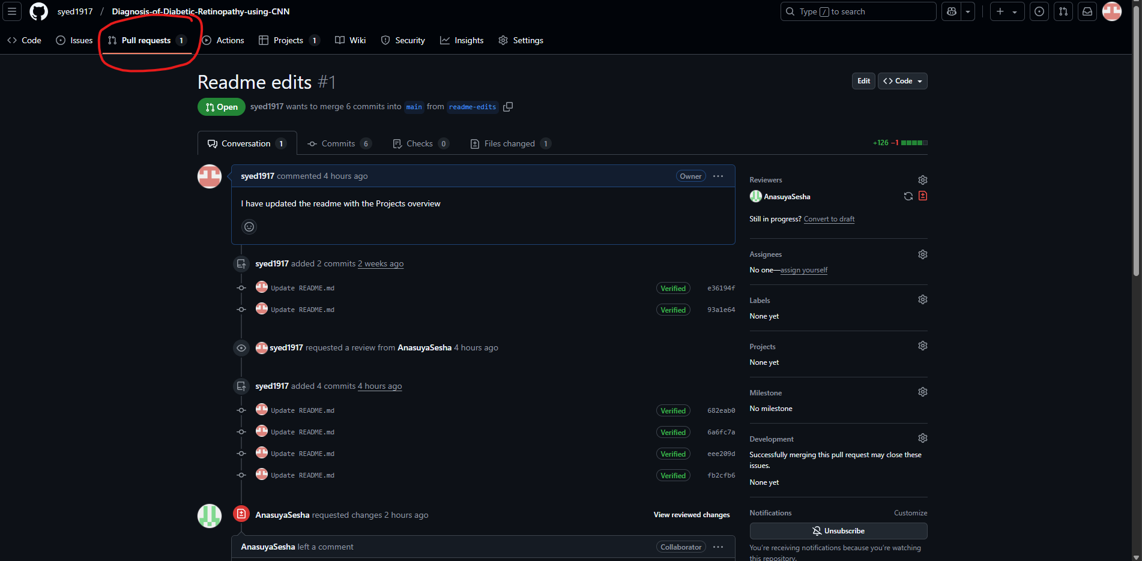

**2.5 Get the GitHub Repository URL**

1. Go to your repository’s main page.
2. Copy the URL from your browser’s address bar. This is your GitHub repository URL.

**Step 3: Collaboration and Communication**

**3.1 Assign Roles and Responsibilities**

1. Define roles for your team members:
   * **Project Manager:** Oversees timelines and deliverables.
   * **Developer:** Writes code and implements features.
   * **QA Tester:** Tests features and reports bugs.
   * **DevOps Engineer:** Manages CI/CD pipelines and integrations.
2. Document these roles in your project documentation.

**3.2 Use Communication Tools**

1. Set up a communication channel (e.g., Microsoft Teams, Slack, or Discord).
2. Share the Azure Boards and GitHub URLs with your team.
3. Regularly update the team on progress using the boards and repository.

**Final Notes**

* **Azure Boards URL:** [<https://dev.azure.com/AIML2025JAN/Diagnosis%20of%20Diabetic%20Retinopathy%20using%20CNN>]
* **GitHub Repository URL:** [[syed1917/Diagnosis-of-Diabetic-Retinopathy-using-CNN](https://github.com/syed1917/Diagnosis-of-Diabetic-Retinopathy-using-CNN)].